**RISK MANAGEMENT**

*Submitted to the*

**SAVEETHA INSTITUTE OF MEDICAL AND TECHNICAL SCIENCES**

In partial fulfillment for the completion of the

**Project**

**by**

Kilari Venkata Sai Sanjana - 192011124 (CSE)

Anumalasetty Jahnavi-192110065(CSE)

**Under the guidance of**

**Dr.K. Vijaya Bhaskar**

**Assistant Professor**



**INSTITUTE of SCience and HUMANITIES**

**SAVEETHA SCHOOL OF ENGINEERING**

**CHENNAI – 602 105**

**TAMILNADU, INDIA**

**September 2022**

**BONAFIDE CERTIFICATE**

This is to certify that the project report entitled **“Risk management”** submitted by “K.Venkata Sai Sanjana - 192011124 (CSE) and A.Jahnavi-192110065(CSE)” , to Saveetha School of Engineering, Saveetha Institute of Medical and Technical Sciences, Chennai, is a record of bonafide work carried out by him/her under my guidance. The project fulfills the requirements as per the regulations of this institution and in my appraisal meets the required standards for submission.

|  |  |
| --- | --- |
| **Dr.K. Vijaya Bhaskar**  Supervisor,  Department of xxxxxxxxxxxx  Saveetha School of Engineering  SIMATS, Chennai – 602 105 |  |

**Internal examiner External Examiner**

|  |  |  |  |
| --- | --- | --- | --- |
| **S.No** | **CONTENTS** | | **Page No** |
| 1 | Abstract | | 5 |
| 2 | Introduction | | 6 |
| 3 | Objectives | | 7 |
| 4 | Literature Review | | 8-9 |
| 5 | Suggestions | | 10 |
| 6 | Data Analysis | | 11-13 |
| 7 | Conclusion | | 14 |
| 8 | References | | 15 |
|  | |
|  | |
|  | |
|  | |

**ACKNOWLEDGEMENT**

I take immense pleasure in expressing my gratitude to our Honourable Chancellor **Dr. N. M. Veeraiyan** for being our constant source of inspiration.

I sincerely thank our Vice-Chancellor, **Prof. Dr. Rakesh Kumar Sharma** for providing the academic ambience to complete the project successfully.

With profound gratitude, respect and pride, I express my sincere thanks to our Director, **Mrs. Ramya Deepak**, whose enthusiasm and dynamism being the driving force behind all our accomplishments.

I take this opportunity to extend our heartiest thanks to our beloved Principal, **Dr.B. Ramesh** for providing us excellent facilities and unstinting support which were the sustaining factors in carrying out the work successfully.

It is a genuine pleasure to express my deep sense of thanks and gratitude to my mentor and my project guide **Dr. K. Vijaya Bhaskar**, Department of Science and Humanities. His timely advice, meticulous scrutiny and scientific approach have helped me to a very great extent to accomplish this task and also his dedication and keen interest had been solely and mainly responsible for completing my work.

Last, but not least, a very special thanks to my parents and friends for their moral support and care extended during the demanding times.

**RISK MANAGEMENT**

**ABSTRACT**

Risk management is a structured approach/methodology for managing uncertainty related to threats; a series of human activities including: Risk assessment, developing strategies to manage it and risk mitigation using resource empowerment/management. Strategies that can be taken include moving risk to other parties, avoiding risks, reducing the negative effects of risk, and accommodating some or all of the consequences of certain risks

The goal of implementing risk management is to reduce the different risks associated with the chosen field at a level acceptable to the community. This can be in the form of various types of threats caused by the environment, technology, people, organizations and politics. The implementation of risk management involves all means available to humans, in particular, to risk management entities as human, staff and organization.

Risk management is important in an organisation because without it, a firm cannot possibly define its objectives for the future. If a company defines objectives without taking the risks into consideration, chances are that they will lose direction once any of these risks hit home.

In recent years, many companies have added risk management departments to their team. The role of this team is to identify risks, come up with strategies to guard against these risks, to execute these strategies, and to motivate all members of the company to cooperate in these strategies. Larger organisations generally face more risks, so their risk management strategies also need to be more sophisticated. Also, the risk management team is responsible for assessing each risk and determining which of them are critical for the business. The critical risks are those that could have an adverse impact on the business; these should then be given importance and should be prioritized. The whole goal of risk management is to make sure that the company only takes the risks that will help it achieve its primary objectives while keeping all other risks under control.

**INTRODUCTION**

Risk is part of the work life of individuals and organizations. Various risks, such as the risk of fire, being hit by another vehicle on the road, the risk of being flooded in the rainy season and so on, can cause us to suffer losses if we do not anticipate these risks from the start.

Risks are associated with possible events or circumstances that can threaten the achievement of organizational goals and objectives. The activities of a business entity or company basically cannot be separated from risk management activities. Operations of a business entity or company usually deal with business risks and non-business risks. In general, risk can be interpreted as a situation faced by a person or company where there is a possibility that is harmful.

Risk management is an important process because it empowers a business with the necessary tools so that it can adequately identify and deal with potential risks. Once a risk has been identified, it is then easy to mitigate it. In addition, risk management

provides a business with a basis upon which it can undertake sound decision-making.

There are five steps in a risk assessment.

1. Identify Risks – If you can think of it, you can prevent it.
2. Prioritize Risks
3. Analyse Risk Response Strategies
4. Plan Risk Response
5. Monitor and Control Risks

Risk assessment is a subjective exercise. The power of the risk assessment does not come from creating the “right” assessment or operating under the belief that all risks will be eliminated; The true value comes from gathering together those individuals involved with the program or activity, having group discussions about risk, and determining what can be done to address risks. Ultimately, it’s not about your municipality having “no risks,” it’s about managing the risks.

**OBJECTIVES**

The objective of risk management is to control risks. When the potential risks are identified, measured, and monitored, then the final objective is to find out ways to deal with or control those risks.

Identifies and Evaluates Risk. Risk management identifies and analysis various risk associated with business organizations:

* Reduce and Eliminate Harmful Threats
* Supports Efficient use of Resources
* Better Communication of Risk within Organisation
* Reassures Stakeholders

**LITERATURE REVIEW**

**Shahroudi et al (2012)- journal of effective risk management**

Shahroudi et al 2012 in support confirmed that reducing exposed risk increase quality of service as well as firms and financial performance, they added that risk management and financial performance has a positive relationship. they revealed that firms with a reputable risk reduction practice produce more revenue and their risk maturity got linked with better return on asset and positive response on risk management.

**Pac 2015- journal of strategic management**

The pac2015 is about the management that lack of risk reduction has been evidenced by the recurring of observations of every year. However it most done on empirical studies on effects on risk management on performances had been done mostly in developed countries and in insurance companies in Kenya. Now a days it is a imp research topic many in business and industrial areas,

**Feririo 2020-Journal of modern transportation**

Feririo 2020 is the risk management review on driverless cars, feririo 2020 is the risk mangement that provided on the driverless cars in 2020 that they are becoming important note readly in society .Driverless cars rely on sensors and a complex system in order to function. However, by the technology it overcome with the driverless feature.

**La and choi 2012-Jouranl of methodology of supply chain**

La and choi are the two persons on risk management that has a positive significant relationship with organisational performance, Wanjohi agreed that risk management has a significant and positive relationship between financial performance of an organization. However, they posted there will be weak responses for our management also. But however, it will if there are strong decision in our management no matter occur whether it is right or wrong.

**Azeredo et al 2014-Journal of risk management**

Azeredo et al (2014) is the journal that provides a process analysis in a structured way to build a consistent theoretical framework that is based on delimination of field of knowledge the selection of database keywords, time filters and criteria for inclusion and exclusion that are misaligned with regard to central theme of research of risk management.

**SUGGESTIONS**

## **1. Be clear about your remit**

Any gaps in responsibilities across your business present an increased opportunity for risk. Make sure that everyone knows exactly what part of the business and what activities and tasks they are responsible for.

## **2. Identify risks early on**

It's never too soon to start thinking about risk. The sooner you do this, the easier it will be to manage the risk. Think about risk management at the start of every project or task. What Early Warning Indicators (EWIs) can we track for different risks? Risk management should be embedded into all of your work processes and corporate culture.

## **3. Be positive**

Not all risks are negatives, so don't only focus on the downsides. Risks can be positive too, presenting and enabling us to take advantage of a given event or situation.

## **4. Describe risk appropriately**

As part of the risk assessment process, it is good practice to create a risk 'string', distinguishing between cause and effect.

## **5. Estimate and priorities risk**

Use a risk matrix to assess and priorities all known risks. You can calculate the severity of a risk by looking at both the probability (likelihood) and impact (severity).

**DATA ANALYSIS**

* **Overall risk taking ability of the organistaion**

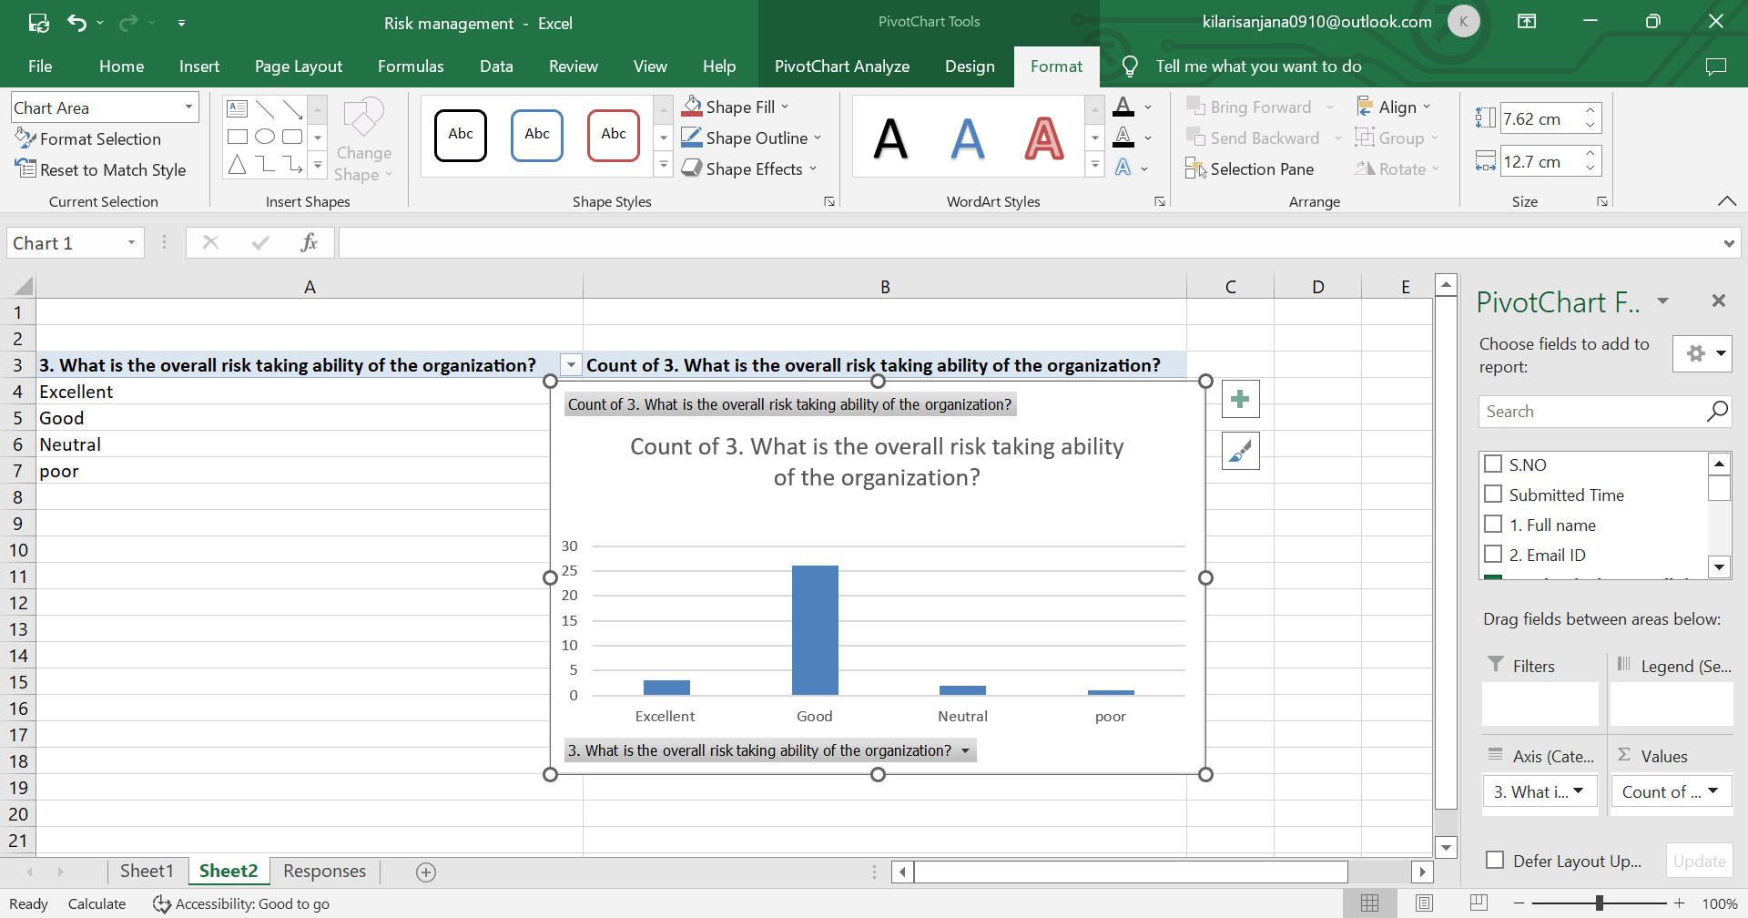

From this survey we can say that the overall risk taking ability of the organisation is good.

* **Risk management in determining the action**

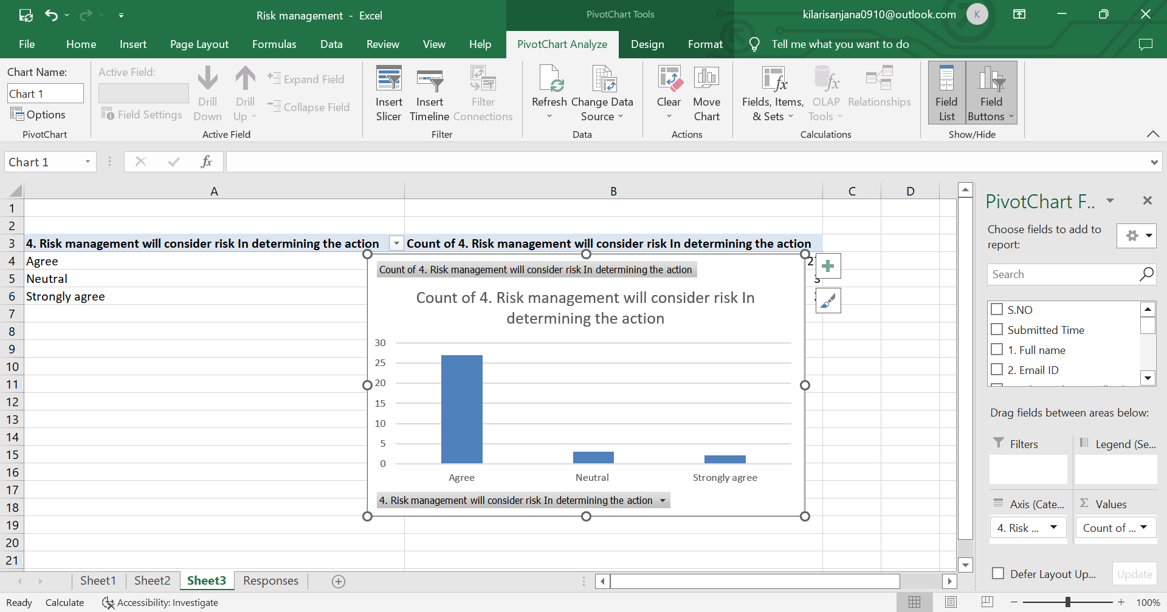

From this survey the overall risk management that will consider the risk determining the action is agreed by everyone.

* **Aware of any type of risks in the oragniation.**

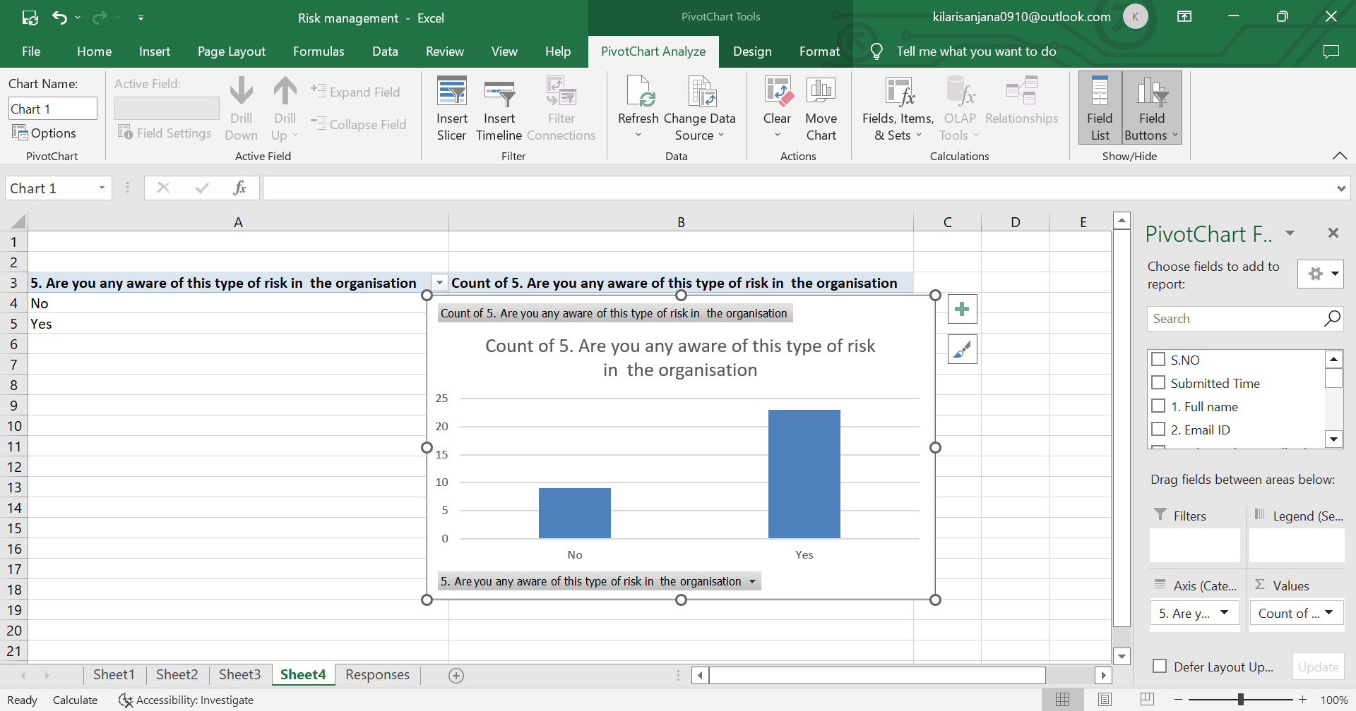

From this survey most of the people have agreed that they are aware of the any type of risk in the organization.

* **Brand reputation**

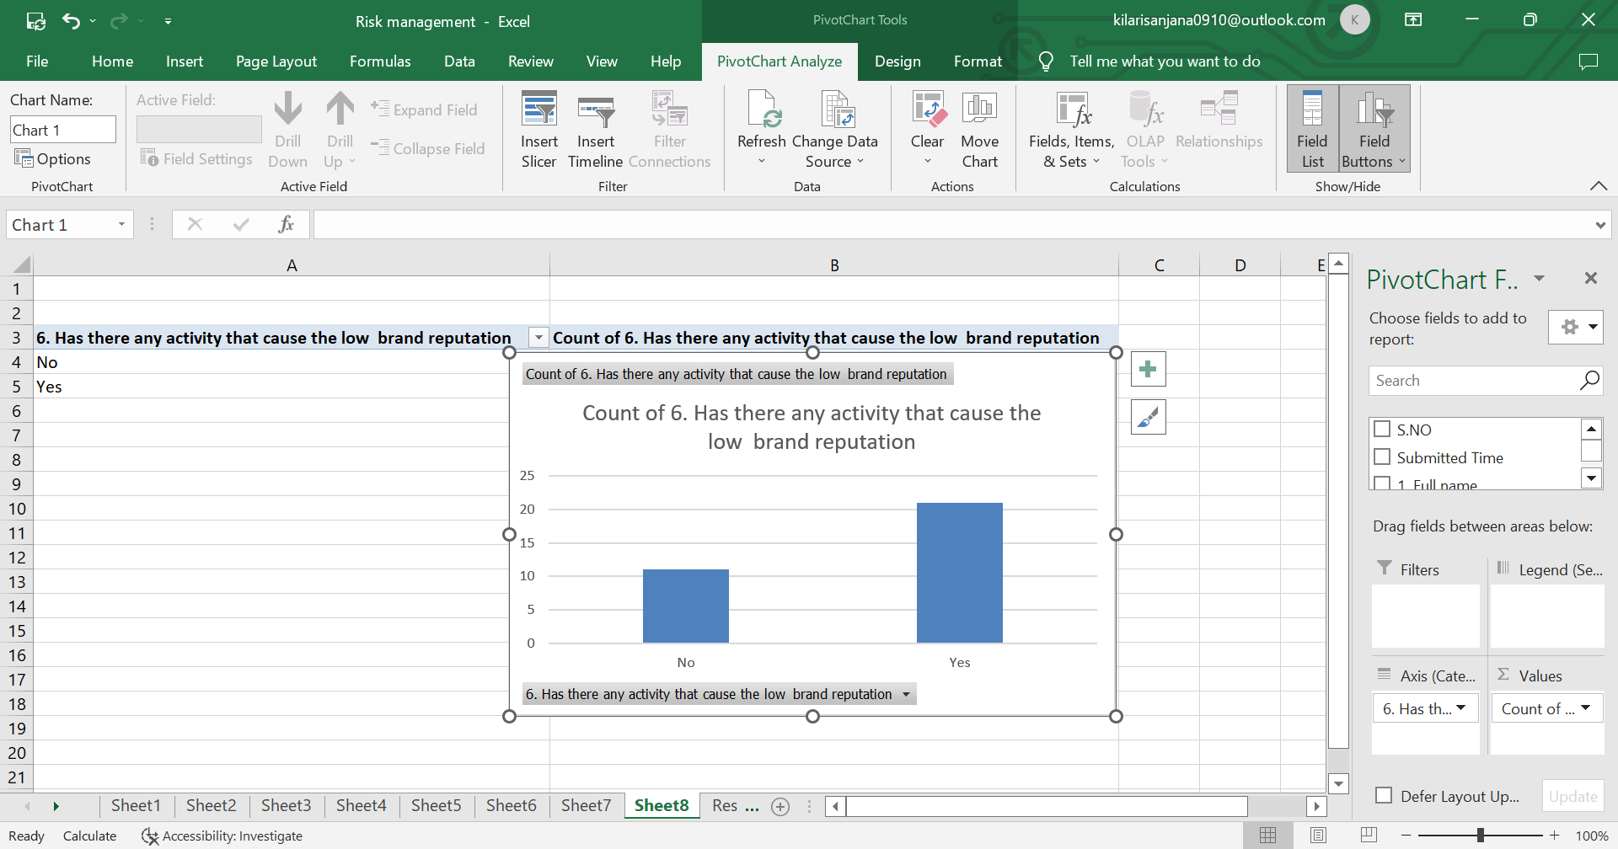

From this survey most of the people have agreed that there are activities that cause the low brand reputation in an organisation.

* **Department in the risk management**

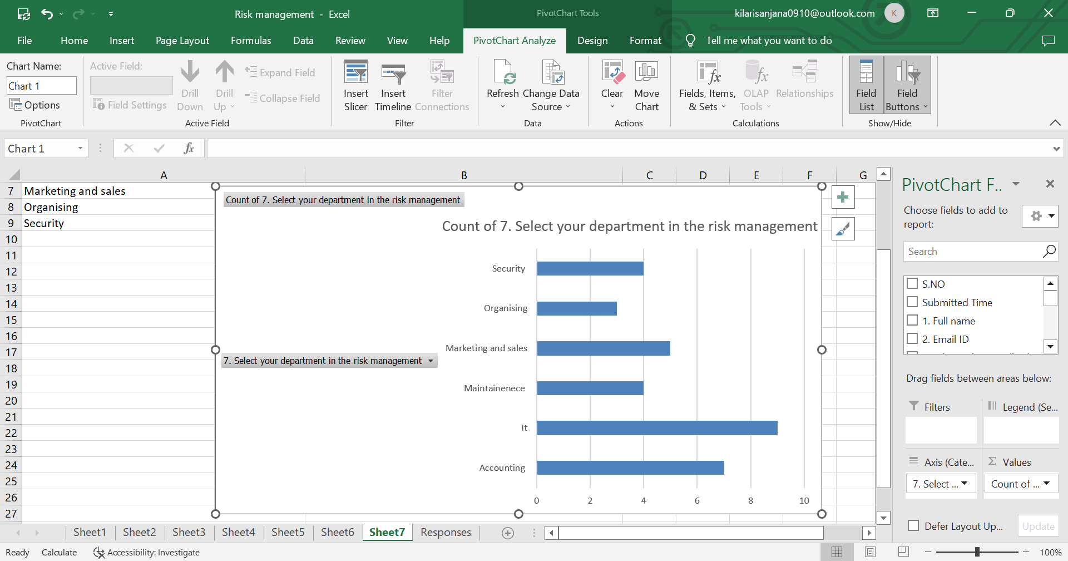

From this survey we can say that least members belong to organising department and most of the people belong to IT department.

* **Rating of risk management**

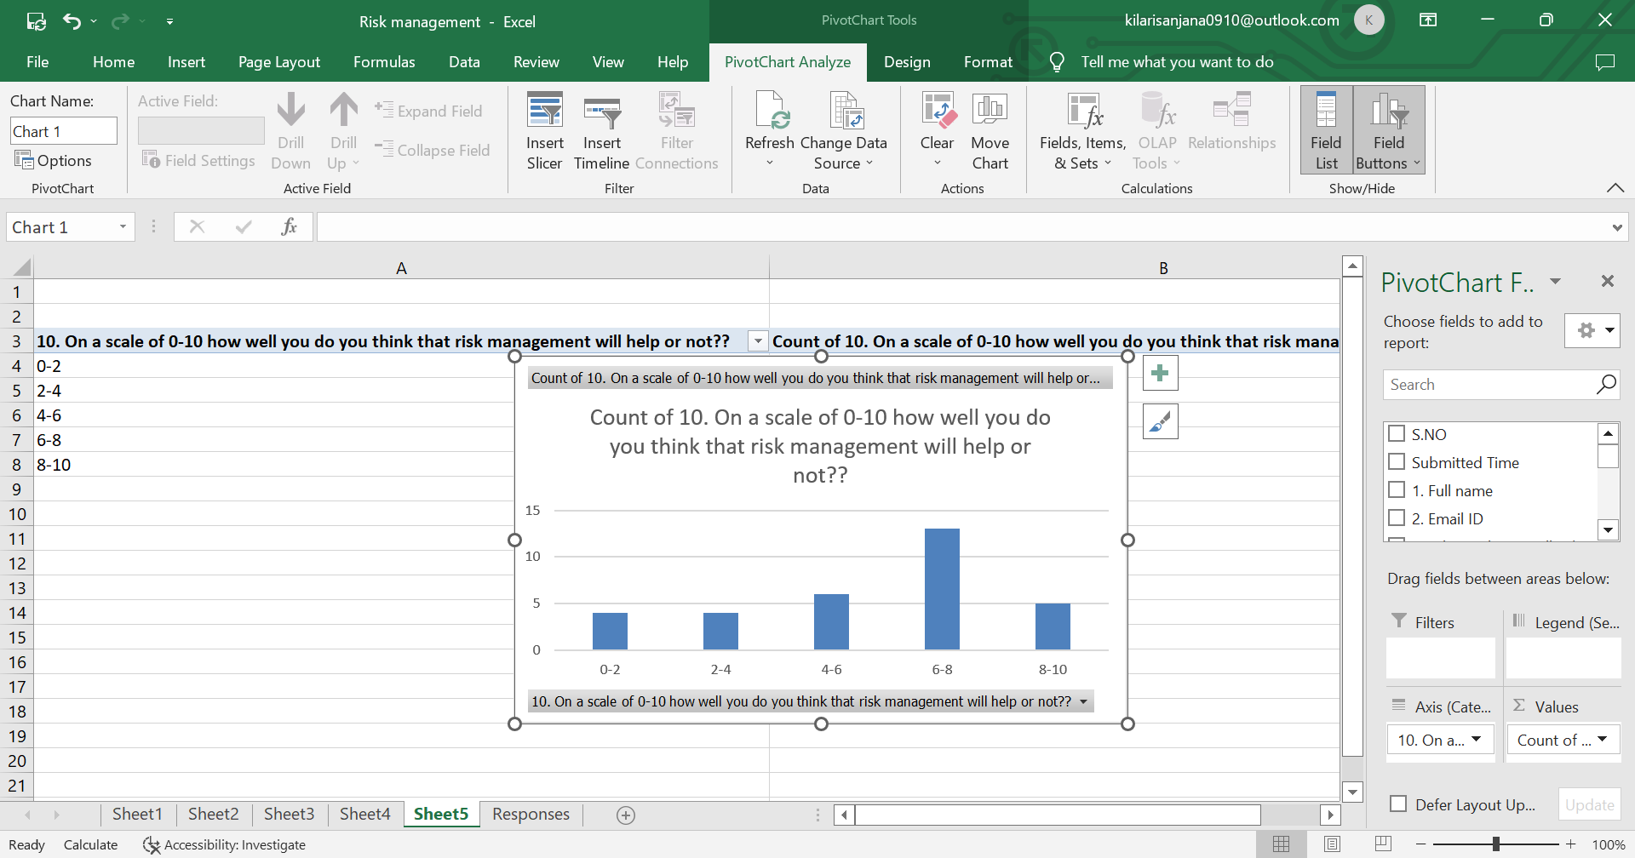

From this survey most of the people giving an analysis on a scale of 6-8 mostly and most of the people think risk management will help in an organisation to suceed.

**CONCLUSION**

Our business ventures encounter many risks that can affect their survival and growth. As a result, it is important to understand the basic principles of risk management and how they can be used to help mitigate the effects of risks on business entities.

There are several areas where progress is required. Development in these areas would have a significant effect on risk management, by producing:

* A set of risk management tools and techniques which are fully integrated with project and business processes, with the existence of uncertainty being recognized and accepted at all levels (via integration of risk management).
* Improved analysis of the effects of risk on project and business performance, addressing its impact on issues wider than time and cost (via increased depth of analysis and breadth of application), and covering both threats and opportunities.
* Proper account being taken of human factors in the risk process, using assessment of risk attitudes to counter systematic bias and build risk-balanced teams (via behavioural aspects).

Attention to these areas will ensure that risk management continues to develop. Risk management must not remain static if it is to fulfil its potential as a significant contributor to project and business success, and if it is to take its place as an indispensable and effective management tool.

**REFERENCES**

* Ali, Mashhud. 2006. Risk Management. Jakarta: PT Raja Grafindo Persada.
* AS/NZS 4360:2004, Australian/New Zealand Standard Risk Management, Joint Technical Committee OB-007 Risk Management, 31 Agustus 2004.
* Committee of Sponsoring Organization (COSO) of the Treadway Commission. What is COSO: Background and Events Leading to Internal Control-Integrated Framework. 1992.
* Chapman, Christy. Bringing ERM into Focus. Internal Auditor, June 2003.
* Darmawi, Herman. Risk Management. Bumi Aksara, 2005.
* Djojosoedarso, Soeisno. Principles of risk and insurance management. 1999. Jakarta: Salemba Empat.
* Iban, Sofyan. 2004. Risk Management. Jakarta: Graha Ilmu.
* Kasidi. 2010. Risk Management. Jakarta: Ghalia Indonesia.
* Mulyawar Setia, 2015, Risk Management, Bandung: CV of Faithful Library.
* Simmons, Mark. COSO Based Auditing. The Internal Auditor, December 1997 The Institute of Internal Auditors. Internal Control
* Simmons, Mark. COSO Based Auditing. The Internal Auditor, December 1997 The Institute of Internal Auditors. Internal Control.
* Sumani. 2009, Risk Management, Mojokerto: Global People.
* Vaughan, Emmet. Fundamental of Risk and Insurance. 2nd, John Willey, 1978**.**